**STIA1123 Programming 2**

**Lab Exercise: User Defined Class**

1. What will be the output from the following code?

class QuestionOne {

private int count;

public void init(){

count = 1;

}

public void increment() {

count = count + 1;

}

public int getCount() {

return count;

}

}

public class Q1Main {

public static void main (String []arg) {

QuestionOne q1;

q1 = new QuestionOne();

q1.init();

q1.increment();

q1.increment();

System.out.println(q1.getCount());

}

}

The answer is 3.

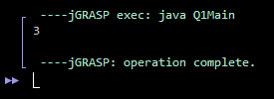

Next, replace the init() method with a constructor. Modify the main() method.

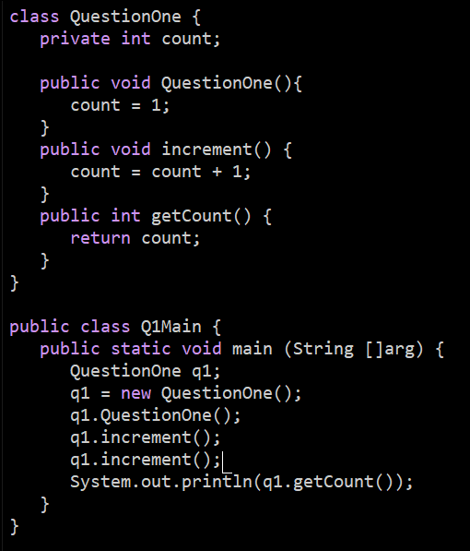



1. Read and analyse the following class:

class Staff {

private String name, staffID;

private double salary;

private int workingDay;

public void setStaffInfo(String nm, String id, int wDay){

name=nm;

staffID=id;

workingDay=wDay;

}

public void calculateSalary(){

salary = workingDay * 35.0;

}

public double getSalary(){

return salary;

}

public String getName(){

return name;

}

public String getStaffID(){

return staffID;

}

}//end class

1. Draw a UML class diagram for Staff class.

|  |
| --- |
| Staff |
| - name: String  - staffID: String  - salary: double  - workingDay: int |
| - setStaffInfo()  - calculateSalary()  - getSalary()  - getName()  - getStaffID() |

1. By using the above class, complete the following class TestStaff that accepts name, staff id and working per day as inputs from the user and displays the name, staff ID and salary of the staff.

import java.util.Scanner;

class TestStaff {

static Scanner console = new Scanner(System.in);

public static void main(String arg[]){

String name, staffID;

int workingDay;

System.out.print(“Staff name?: “);

name = console.next();

System.out.print(“Staff ID?: “);

staffID = console.next();

System.out.print(“How many days of work?: “);

workingDay = console.nextInt();

double salary = workingDay * 35.0;

System.out.print(“Name: “+ name);

System.out.print(“ID: “+ staffID);

System.out.print(“Working days: “+ workingDay);

System.out.print(“Salary: “+ salary);

}

}//end class

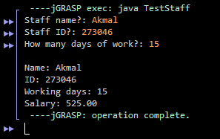

1. Understand and analyze the problem below:

Staffs at MyFC earn the basic hourly wage of RM8.00. They will receive a commission on the sales they generate while tending the counter. The commission is based on the following formula:

|  |  |
| --- | --- |
| **Sales Volume** | **Commission** |
| RM150.00 to RM300.00  RM301.00 to RM500.00  Above RM500.00 | 5% of total sale  10% of total sale  15% of total sale |

Based on above scenario:

* Write a Java program that accepts staff’s information (including name and staffID), total hours work and total sales for that particular month and then displays total salary that he/she earned. You are required to create 2 classes named MyFCStaff and TestMyFCStaff. Declare appropriate data members for the class MyFCStaff and include the following methods as well:
  + **Constructor** - to initialize name, staffID, total hours work and total sales for that particular month with values that are received through the parameters of the method.
  + **calculateCommission()** - calculates the commission based on the sales volume.
  + **calculateSalary()** - calculates the total salary
  + **displaySalary()** - displays the output similar as shown below

Staff Name : Ali

StaffID : MyFC1001

Hours Work : 200

Total Sale : RM 4500.00

Total Salary : RM 2275.00

* The class TestMyFCStaff will contain the main method that consists of the statements to read the user input and invoke the methods of the class MyFCStaff.

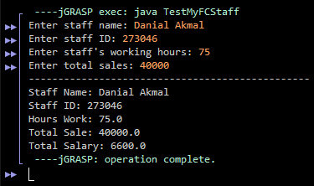

1. Modify the class MyFCStaff by replacing the **displaySalary()** method with the method toString() that returns all required information to be displayed as the output as shown in the above. You should then include printing statements (S.O.P) in the main method. Please ensure that you should get the same expected output as in the **Question (3**).

